Birdhouse
2022/04/01 Ben Larcher
www.graineahumus.org

Version 0.1

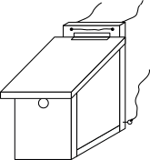


Blueprints for various species
Sommaire
Cutting 1
Sizes 2
Type 1 2
Type 2 3
Type 3 4
Type 4 5
Type 5 6
Type 6 7
Type 7 8
Assembly 9
Material summary 11
Wood 11
Hinge 11
Clasp 11
Fasteners 11
Ion wire 11
Material 11
Details 12
Questions ? 12
Resources 12

Cutting
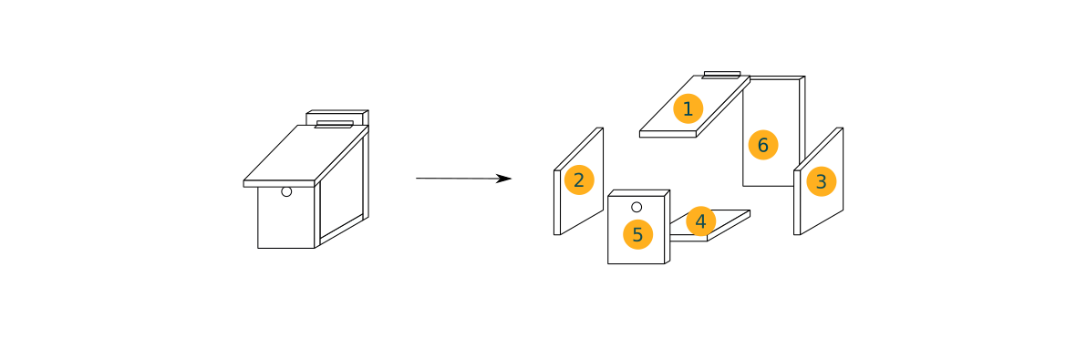
Exploded view of the birdhouse.

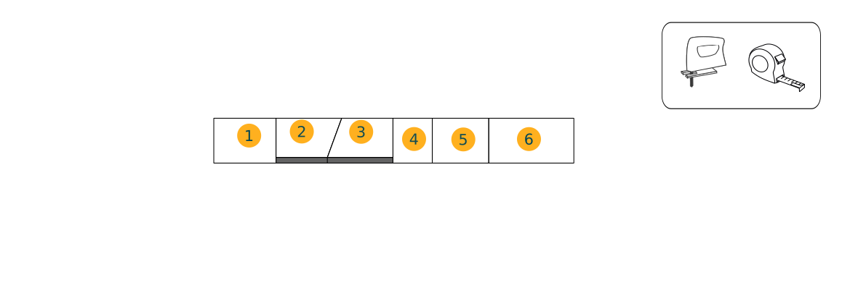
To save wood, these blueprints can be made with a single board.

Sizes
Piece size varies by species. Here is a summary table of sizes.

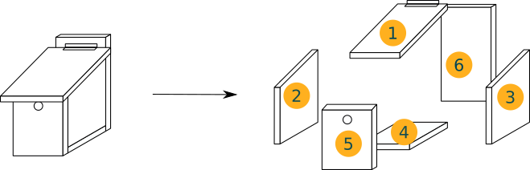
Type 1
For eurasian blue tit, marsh tit, european crested tit or coal tit
 | Dimensions (in cm)
1-Removable roof | 17 + e (depth)  18 + 2 e (width)
2 et 3-Sides | 14 (width)  25 - e (front side)  28 - e (back side)
4-Bottom | 14 (depth)  14 + 2 e (width)
5-Front with hole | 25 (height)  14 + 2 e (width)  28 mm diameter hole
6-Back | 35 (height)  14 + 2 e (width)

e is the thickness. If the board is 1.8 cm thick, then 2 e = 1.8 x 2 = 3.6 cm.

Type 2
For great tit, tree sparrow, pied flycatcher
 | Dimensions (in cm)
1-Removable roof | 17 + e (depth)  18 + 2 e (width)
2 et 3-Sides | 14 (width)  25 - e (front side)  28 - e (back side)
4-Bottom | 14 (depth)  14 + 2 e (width)
5-Front with hole | 25 (height)  14 + 2 e (width)  32 mm diameter hole
6-Back | 35 (height)  14 + 2 e (width)

e is the thickness. If the board is 1.8 cm thick, then 2 e = 1.8 x 2 = 3.6 cm.

Only the front hole changes from the previous dimensions.
By opting for this size, it is likely that species from the previous blueprint will live there, given the small differences.

Type 3
For Eurasian nuthatch, common redstart
 | Dimensions (in cm)
1-Removable roof | 17 + e (depth)  18 + 2 e (width)
2 et 3-Sides | 14 (width)  25 - e (front side)  28 - e (back side)
4-Bottom | 14 (depth)  14 + 2 e (width)
5-Front with hole | 25 (height)  14 + 2 e (width)  Oval hole 32mm wide by 48mm high
6-Back | 35 (height)  14 + 2 e (width)

e is the thickness. If the board is 1.8 cm thick, then 2 e = 1.8 x 2 = 3.6 cm.

Type 4
For common starling
 | Dimensions (in cm)
1-Removable roof | 19,5 + e (depth)  20 + 2 e (width)
2 et 3-Sides | 16 (width)  30 - e (front side)  34 - e (back side)
4-Bottom | 16 (depth)  16 + 2 e (width)
5-Front with hole | 30 (height)  16 + 2 e (width)  Oval hole 45mm wide by 50mm high
6-Back | 41 (height)  14 + 2 e (width)

e is the thickness. If the board is 1.8 cm thick, then 2 e = 1.8 x 2 = 3.6 cm.

Type 5
For Eurasian hoopoe
 | Dimensions (in cm)
1-Removable roof | 23,5 + e (depth)  24 + 2 e (width)
2 et 3-Sides | 20 (width)  33 - e (front side)  36 - e (back side)
4-Bottom | 20 (depth)  20 + 2 e (width)
5-Front with hole | 33 (height)  20 + 2 e (width)  Oval hole 65mm wide by 70mm high
6-Back | 43 (height)  20 + 2 e (width)

e is the thickness. If the board is 1.8 cm thick, then 2 e = 1.8 x 2 = 3.6 cm.

Type 6
For Eurasian hoopoe, Eurasian scops owl, Stock Dove, common starling
 | Dimensions (in cm)
1-Removable roof | 19,5 + e (depth)  22 + 2 e (width)
2 et 3-Sides | 16 (width)  33 - e (front side)  35 - e (back side)
4-Bottom | 16 (depth)  16 + 2 e (width)
5-Front with hole | 33 (height)  16 + 2 e (width)  90 mm diameter hole
6-Back | 42 (height)  16 + 2 e (width)

e is the thickness. If the board is 1.8 cm thick, then 2 e = 1.8 x 2 = 3.6 cm.

Type 7
For tawny Owl
 | Dimensions (in cm)
1-Removable roof | 35 + e (depth)  26 + 2 e (width)
2 et 3-Sides | 22 (width)  55 - e (front side)  57 - e (back side)
4-Bottom | 22 (depth)  22 + 2 e (width)
5-Front with hole | 55 (height)  22 + 2 e (width)  120 mm diameter hole
6-Back | 64 (height)  22 + 2 e (width)

e is the thickness. If the board is 1.8 cm thick, then 2 e = 1.8 x 2 = 3.6 cm.

Assembly
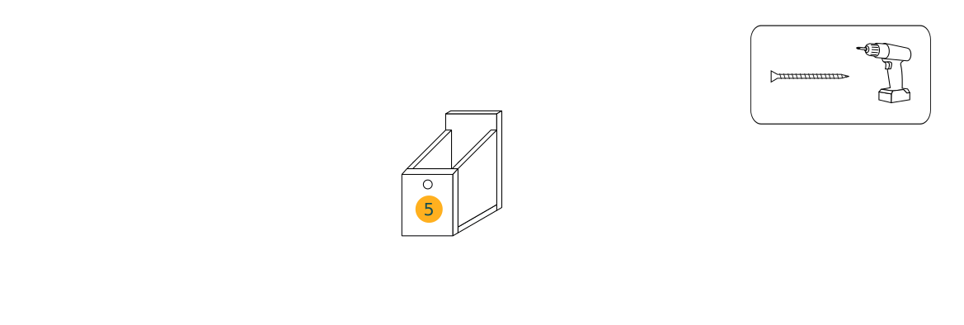
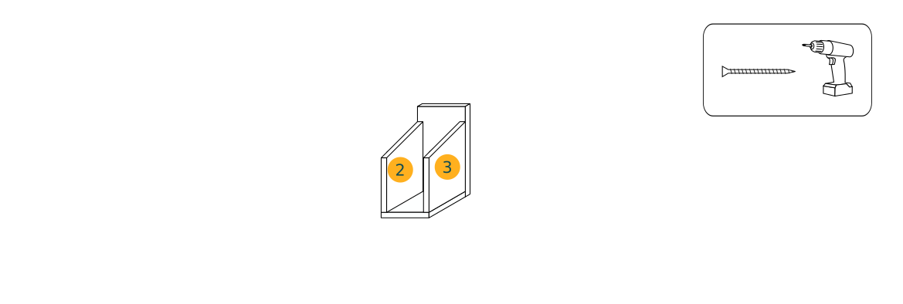
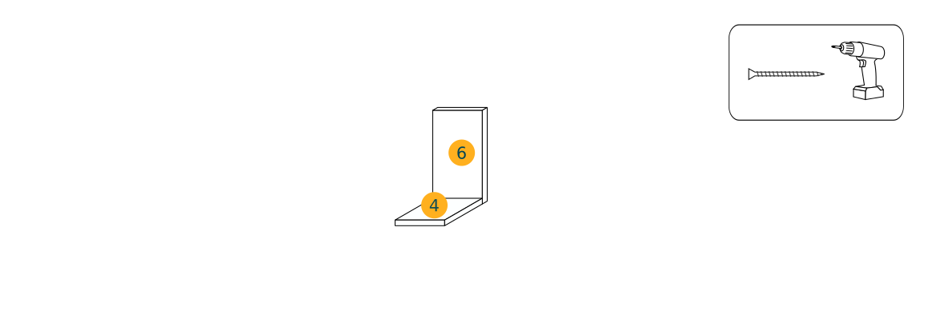
1
2
3
Screws 40 mm
Screws 40 mm
Screws 40 mm
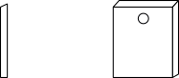 | If you look from the side, there is a slight bevel on the front part (5). This is to be aligned with planks 2 and 3 on the side. Thus, once the roof is installed, everything is airtight.  The hole is made with a hole saw.  The hole is placed high to avoid falling chicks.

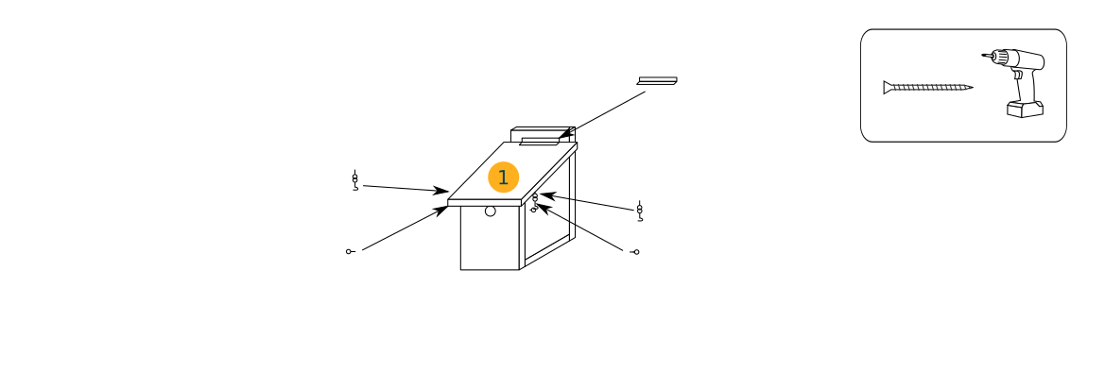
Screws 15 mm
We center the roof with 2 cm overhang on each side.
A hinge is installed on the roof and a clasp system for easy access for maintenance.
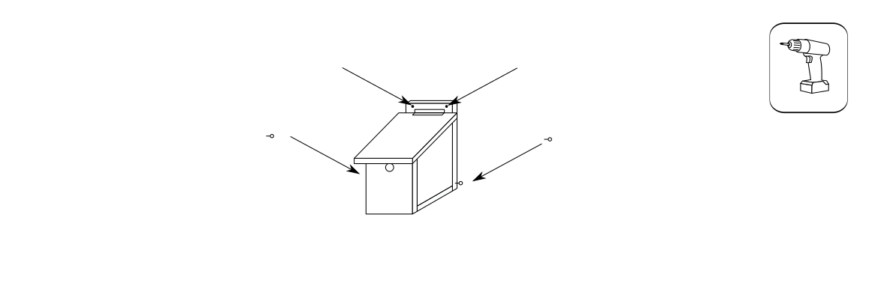
We pierce the bottom board and place pitons. This allows the wire to pass through.
6



Material summary

Wood
The wood is a class 3 untreated wood made to be outdoors.

Hinge
1 hinge for the roof.

Clasp
2 clasp systems on the sides of the roof. This allows easy opening for maintenance.

Fasteners
Wood screws : 40 and 15 mm.
40 mm: about 20.
15 mm: about 6.
To avoid splitting, there are anti-splitting screws (or it is better to drill before screwing)

Ion wire
1 to 2 m to hang the birdhouse.

Material
- Tape measure
- Jigsaw
- Drill / screwdriver (with a hole saw)

Details
Find details on https://habitat.seedtohumus.org/ concerning the heights, orientations, advice to avoid damaging the tree, maintenance...

Questions ?
If you have any questions, go to https://habitat.seedtohumus.org/ and ask them in the article dedicated to the subject.

Resources
Blueprints numbers 1, 2, 3, 4 and 5 are inspired by the Swiss Association for the Protection of Birds.
Blueprints numbers 6 and 7 are inspired by the LPO Drome Ardèche.

